
Pamela Michell Galvis Alvarez
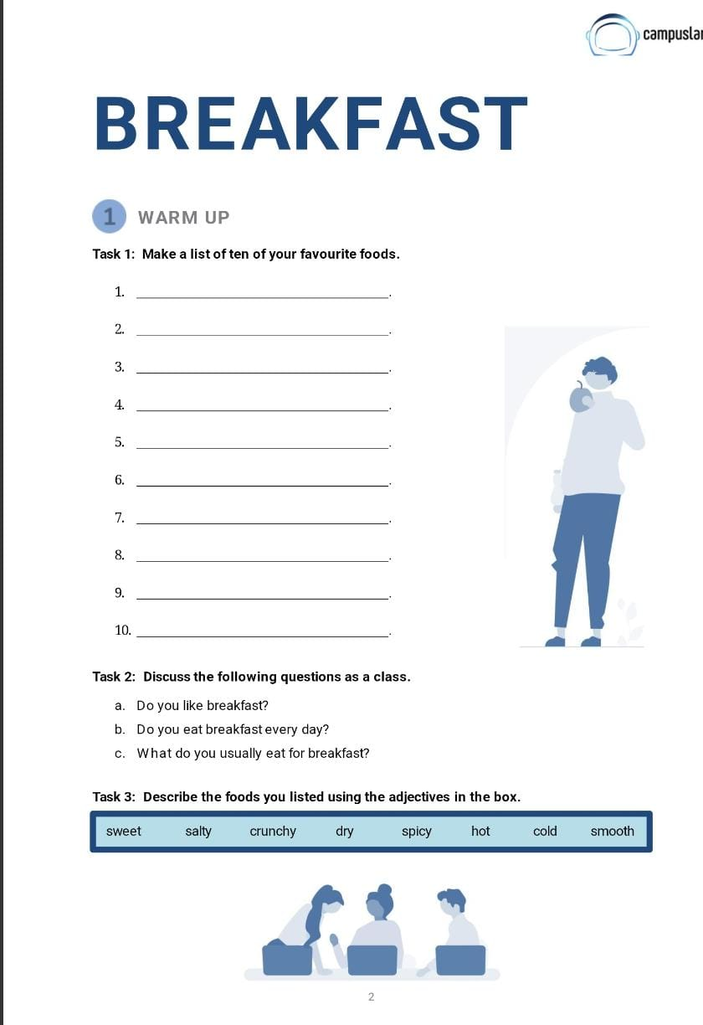
Yes, I love breakfast!
Yes, I eat breakfast every day.
I often have cereal with milk.
Pizza

Paste

Hamburgers

Chocolate

Sushi

Tacos

ice cream

french fries

Chicken soup

Apples
Pizza: Salty, hot
Pasta: Hot, smooth (referring to sauce)
Hamburgers: Salty, hot
Chocolate: Sweet, smooth
Sushi: Cold, smooth
Tacos: Spicy (if you add chili), hot, crunchy (if with hard shells)
Ice cream: Sweet, cold, smooth
French fries: Salty, hot, crunchy
Chicken soup: Hot, salty
Apples: Sweet, crunchy, cold
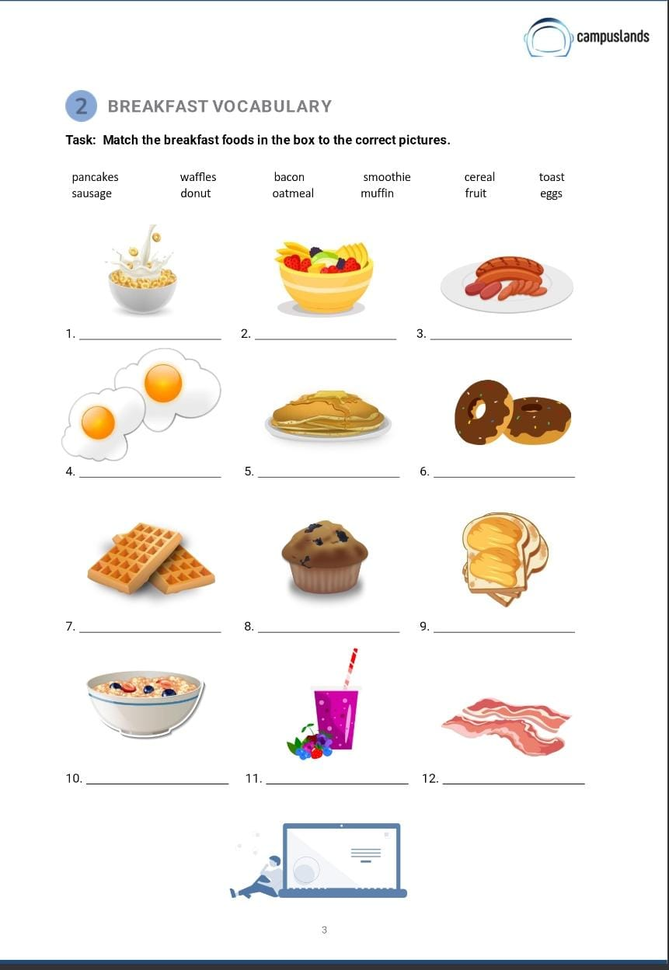
oatmeal
waffles
bacon
cereal
sausage
fruit
eggs
toast
donut
smoothie
pancakes
muffin
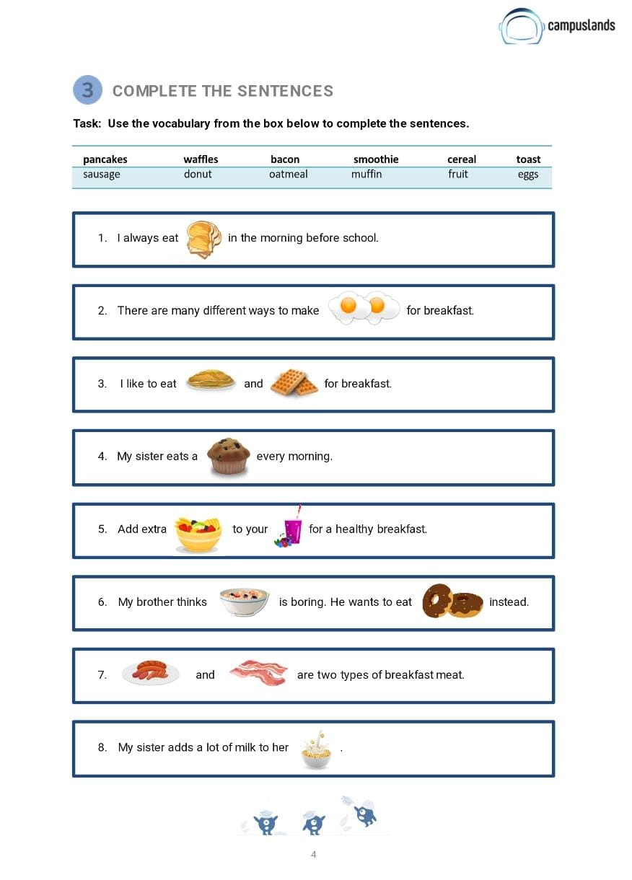
toast
smoothie
fruit
muffin
waffles
pancakes
eggs
oatmeal
donut
sausage
bacon
cereal
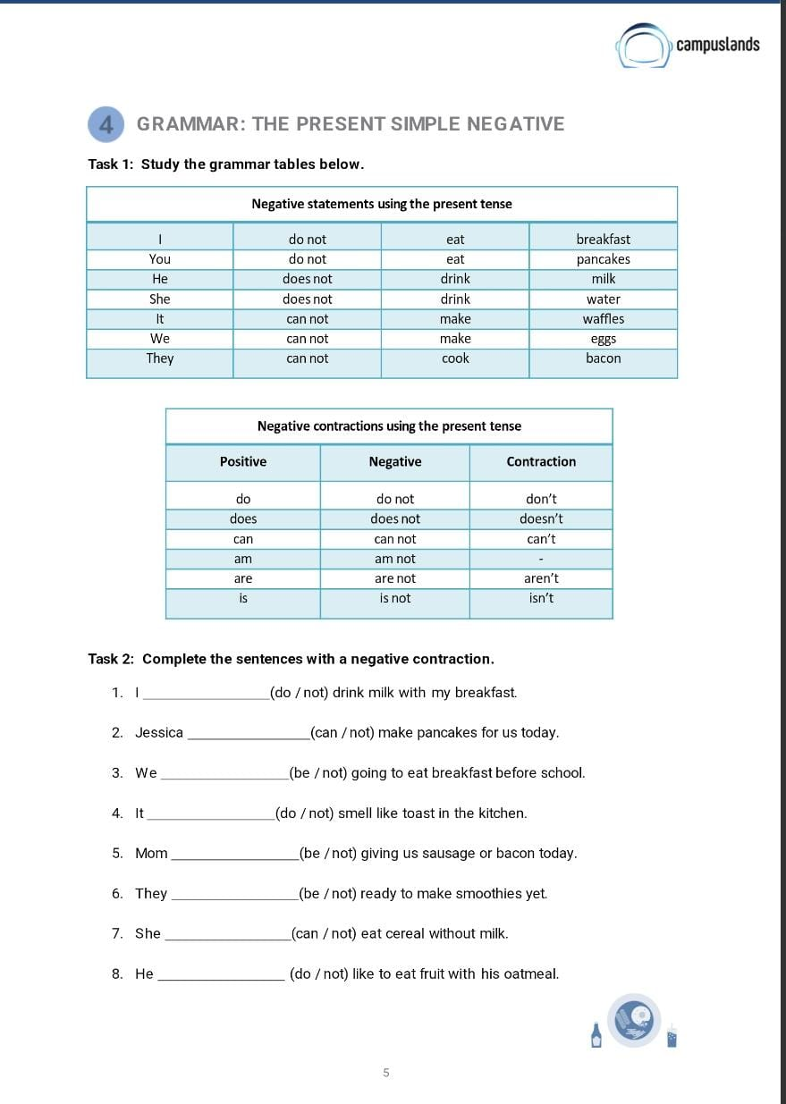
don’t
can’t
don’t
can’t
aren’t
isn’t
doesn’t
aren’t
doesn’t
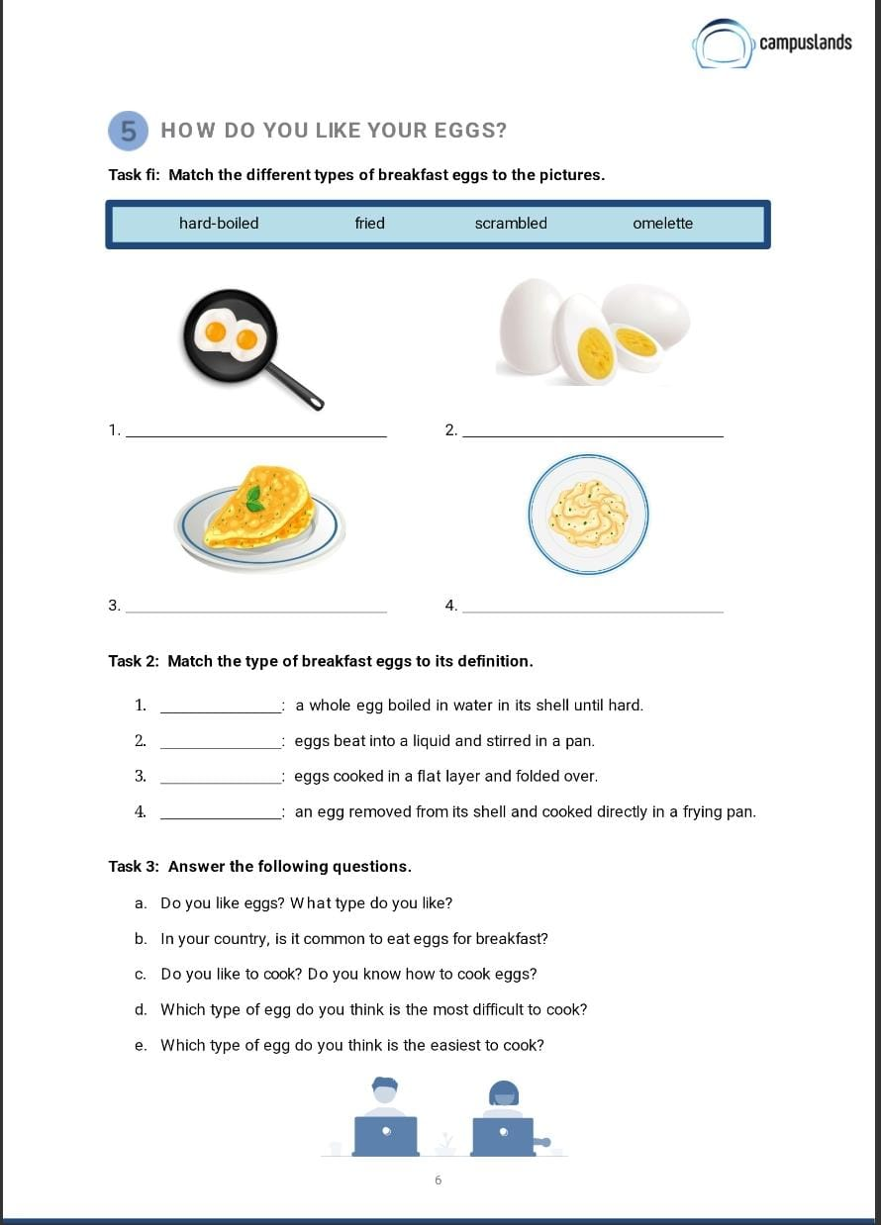
fried
Hard-boiled
scrambled
omelette
fried
omelette
scrambled
Hard-boiled
a. Do you like eggs? What type do you like?
Yes, I like eggs very much! I especially like scrambled eggs and fried eggs.
b. In your country, is it common to eat eggs for breakfast?
Yes, it's very common to eat eggs for breakfast in Colombia. Many people eat scrambled eggs (pericos) with bread or arepas.
c. Do you like to cook? Do you know how to cook eggs?
Yes, I like to cook. And yes, I know how to cook scrambled eggs, fried eggs, and hard-boiled eggs.
d. Which type of egg do you think is the most difficult to cook?
I think making a perfect omelette can be the most difficult, because you have to fold it nicely.
e. Which type of egg do you think is the easiest to cook?
I think hard-boiled eggs are the easiest to cook, you just put them in boiling water.

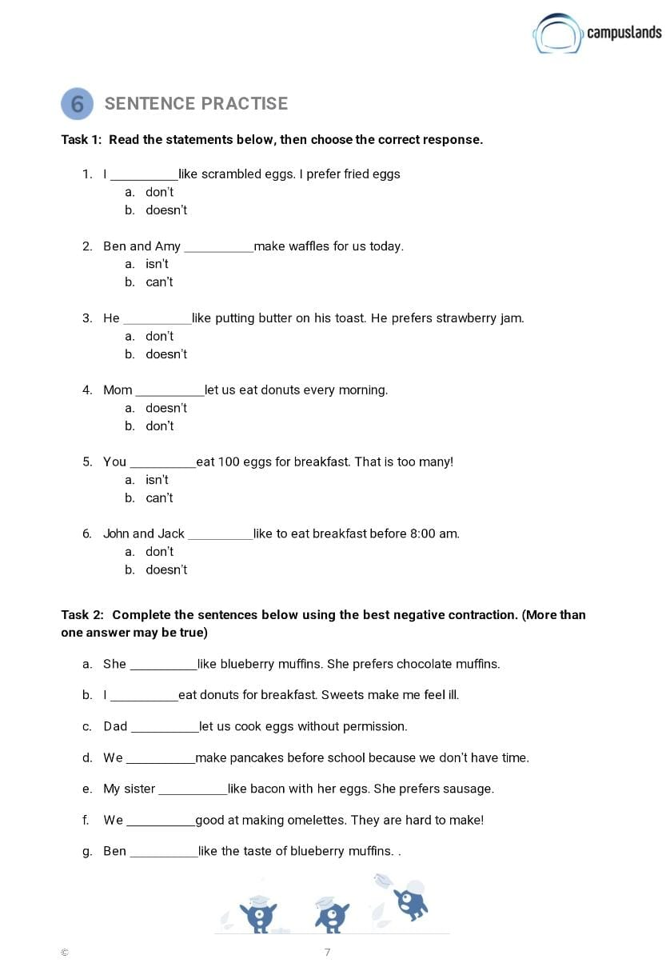
don’t
can’t
doesn’t
doesn’t
can’t
don’t
doesn’t
don’t
doesn’t
can’t
doesn’t
aren’t
doesn’t

